Need something a little different?
If you’re looking for support that is built around your lifestyle and routines, we can find a Care Support Worker or Personal Assistant that suits you.
Whether you’re looking for extra support at work, at university or regular assistance to help you stay in your own home, we’ll match you with the right person who will help you to continue living at home (including considering personalities, interests, languages and cultures in Enfield).

STAFF

Ensuring the right fit

Pamela Burke, CEO
Hello,
I’m the Chief Executive here at Enfield Carers Homecare. I grew up and live in Enfield, so I know the borough well.
Our experienced and dedicated team of Care Support Workers provide hundreds of hours of care to people in their homes every week.
We understand your loved one’s safety is paramount. That’s why we go to great lengths to ensure their Care Support Worker is someone your whole family can trust.
All our staff have full background checks, referencing and certificates to prove they reach the standards you expect.
Only the most trusted and enthusiastic people are selected to work for Enfield Carers Homecare Service.
Whatever your situation, you can take comfort from knowing that as a charity, we are here for you, not for profit.”

Trained, experienced staff
In line with CQC regulations, our staff complete 15 Standards of Care made up of both mandatory and non-mandatory training.
To achieve their Care Certificates, staff will typically complete training in:
- Duty of Care
- Equality and Diversity
- Working in a Person-Centred Way
- Communication
- Privacy and Dignity
- Fluids and Nutrition
- Awareness of Mental Health, Dementia and Learning Disabilities
- Safeguarding Adults
- Safeguarding Children
- Basic Life Support
- Health and Safety
- Handling Information
- Infection Prevention and Control
- Moving & Handling
- Medication

Meet some of our Homecare team
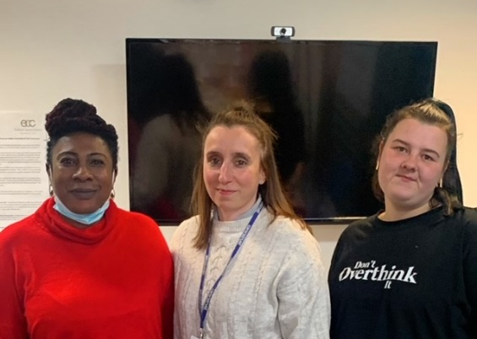

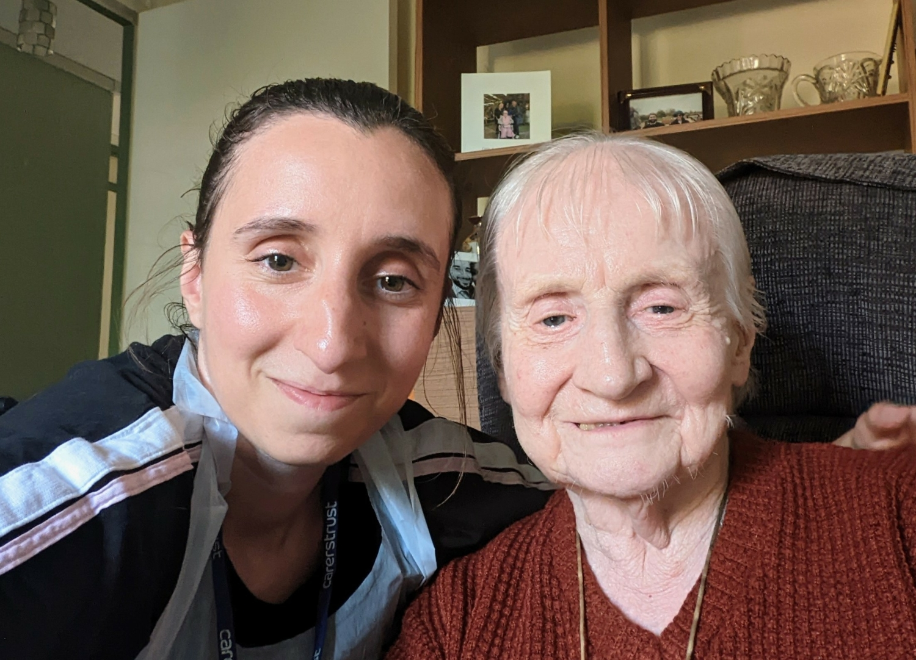

Call Us Now
020 4519 2654

CARE

Replacement Care
Are you struggling to find time for yourself, attend your own medical appointments or perform regular household tasks e.g. shopping etc. because you can’t leave your loved one whilst you go out? We can help.
Once you’ve registered with Enfield Carers Centre (ECC), we’ll carry out an assessment of your loved one’s health care needs and make arrangements with you to timetable when the replacement care takes place.
Replacement care visits are for a minimum of 1 hour. For pricing see the information below.

Free replacement care* to attend ECC activities
We understand that not everyone has family or friends who can be with your loved one when you take some time out to visit the Carers Centre for an appointment or to enjoy one of our training or other activities. If you cannot leave your loved one but would like to book one of our activities e.g. attend one of our Carer support groups, call our office to book free replacement care*.
If you’ve not used our homecare services before, we will need to arrange an assessment of your loved one’s healthcare needs before agreeing to provide replacement care. The assessment will ensure that we fully understand their needs, likes and dislikes and so that we can provide one of our qualified team best suited to care for them whilst you’re away from home.
Contact:
Enfield Carers Centre – 020 4519 2654 or 020 8366 3677, or email: homecare@enfieldcarers.org
* Subject to criteria and availability

COST

What will it cost?

Our prices – we can be competitive because we are not-for-profit
Our pricing structure is competitive, fair and transparent. Our prices are based on a one-hour minimum visit as we believe that quality care takes time.
Call the office on 020 4519 2654 or 020 8366 3677 to discuss your care needs and to ask for a Homecare quote.
Homecare rates for new clients are:
- Monday to Friday – 08:00 to 20:00 – £29.70 per hour
- Monday to Friday – 20:00 to 08:00 – £31.90 per hour
- Saturday & Sunday – any time – £31.90 per hour
Sleeping night or Waking night care is for a minimum of 10 hours from £264 or £319.

Different ways to pay for Homecare
If the person receiving care has their own money/income e.g. pension, disability benefits or savings, you can pay us directly for their homecare services by credit/debit card or online payment. We will send an invoice each month.
You may be entitled to help from social services to pay for or contribute to the cost of homecare services. Talk to one of our Support Workers who can explain the council’s assessment process to you.
People often think home care is unaffordable. We can support and help you to claim everything that you are eligible for:
- Claim all the benefits you’re entitled to
- Apply for NHS Continuing Healthcare
- Get funding from your local council
- Use your assets

See our more detailed information about these subjects:
- Will the council pay for homecare?
- Financial support to pay for homecare
- How means testing works
- Care fees and my home
Find Out More

GET IN TOUCH

Feel free to contact us
For a quote or a chat about prices, or if you have any questions about our services, please call us on 020 4519 2654 or send an email to homecare@enfieldcarers.org

Call Us Now
020 4519 2654
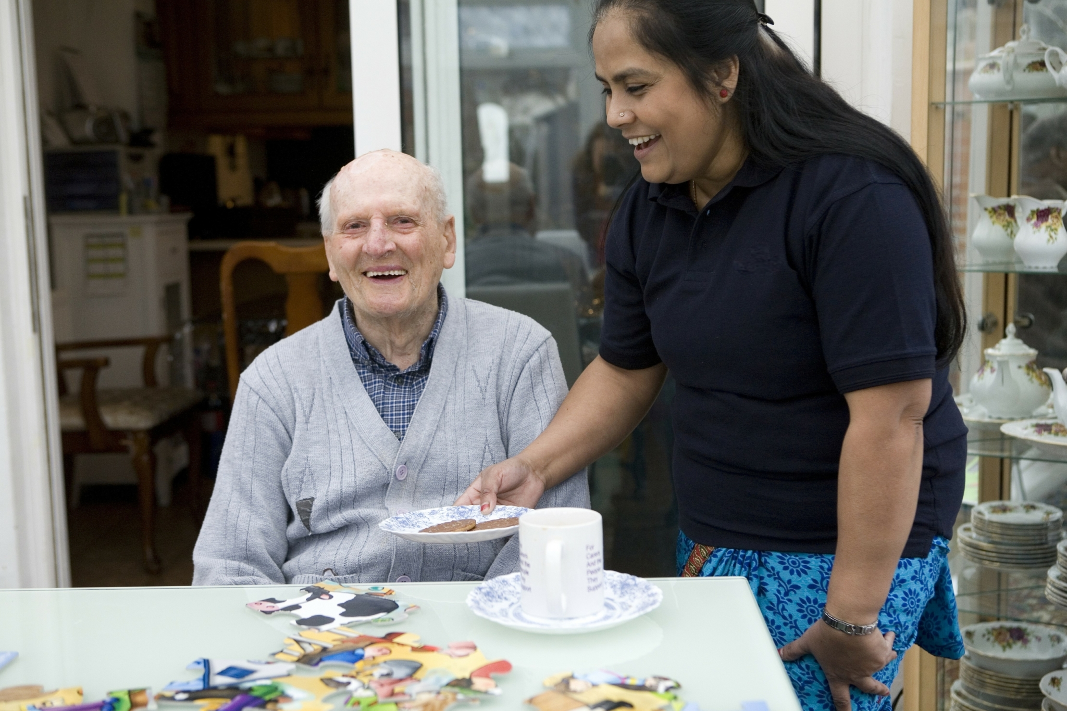

REVIEW

What our clients say about us
“although we initially booked a few hours care, we soon increased this as the care provided put a smile back on M’s face” MZ
“The service is brilliant, and staff are worth their weight in gold” SG
“I can confidently go out knowing that dad is in capable hands and that mum can get on with whatever it is she wants to do without worrying about dad” IP
“I enjoyed my holiday more in the knowledge C was being well cared for” EF
Click here to read other reviews or tell us about your own experience on Google Reviews.

If you would like to print the Enfield Carers Centre Homecare leaflet in a community language, please click the relevant link below.

Albanian Homecare

Arabic Homecare

Bengali Homecare

Bulgarian Homecare

Greek Homecare

Romanian Homecare

Somali Homecare

Turkish Homecare

Urdu Homecare

Register with us to use our services, keep up to date
and receive useful emails.
Carers will join our Carers Register, receive free newsletters, monthly bulletins and other useful advice and information.
Carers
Professionals can also receive regular updates about our services and latest newsletters.
Professionals

Safeguarding Policy Information

Useful Links
- Adult Carers
- Young Carers
- Homecare
- Day care
- Help and Advice
- For Professionals
- About Us
- Newsletter & Annual Report
- Contact Us

Registered Charity
Charity Registration No: 1140089
Company No: 7149774

Enfield Carers Centre is committed to reducing its impact on the environment, supporting Enfield Council in achieving its local environmental plans. We are aiming to reduce our emissions by 90% by 2050.
In order to do this, we have introduced a number of measures which encourage a “Reduce, Reuse, Recycle” agenda and we encourage our staff to run a “greener” office approach wherever possible. Click here to see a full copy of our Carbon Reduction Plan.
© Enfield Carers Centre 2026 | All Rights Reserved | Powered By Telsa Media

